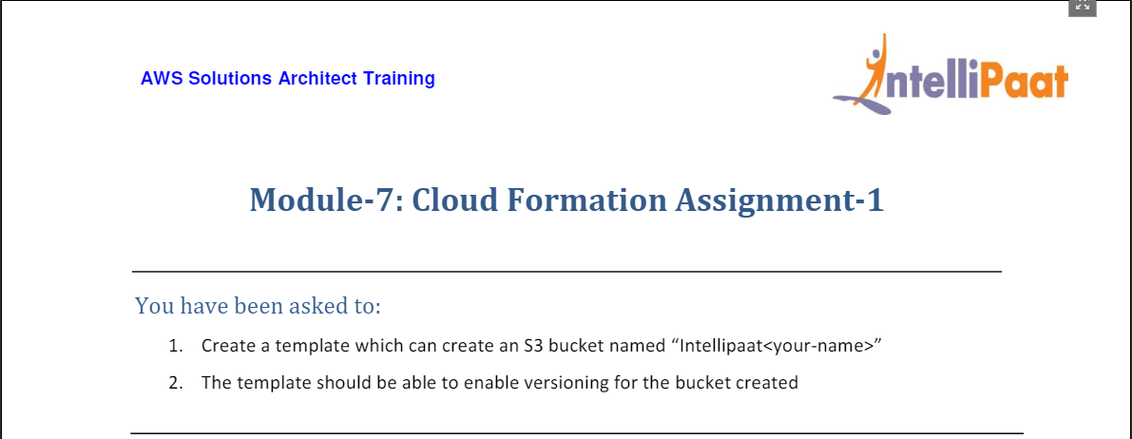

1. From AWS Home Console, select CloudFormation Service

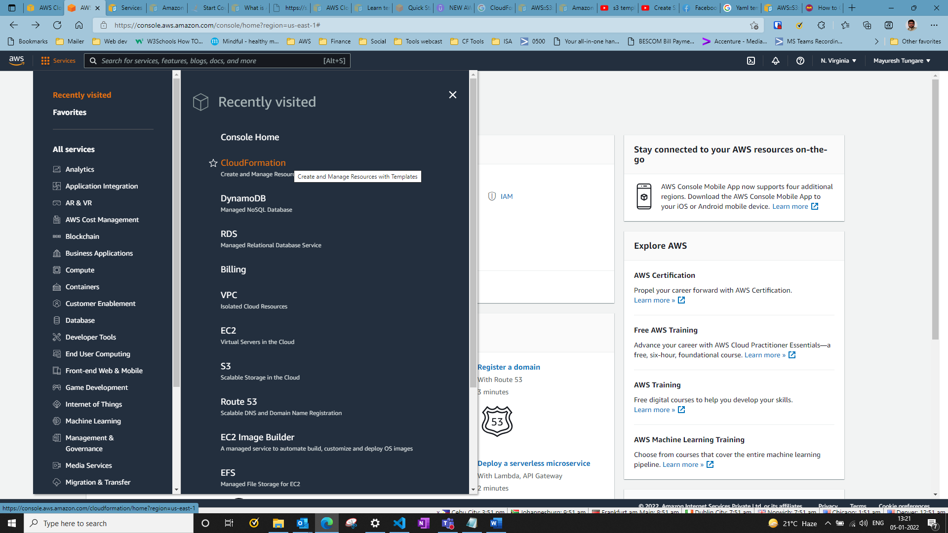

1. Next Click on ‘Create Stack’

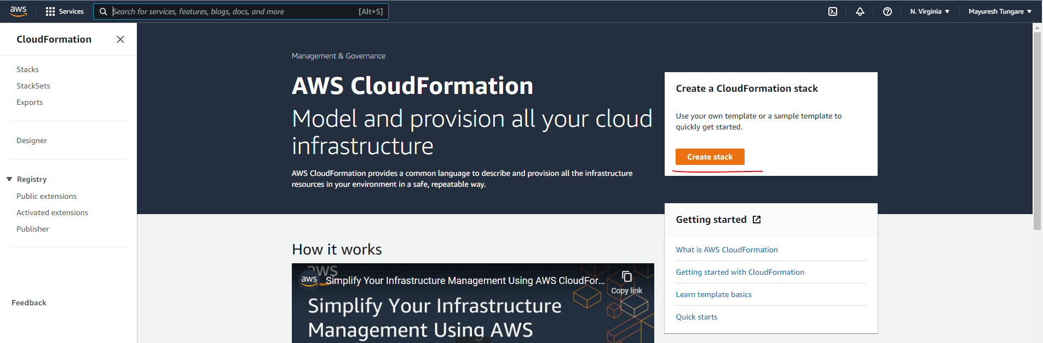

1. Next choose option ‘Create template in Designer’ and click on Create template in Designer

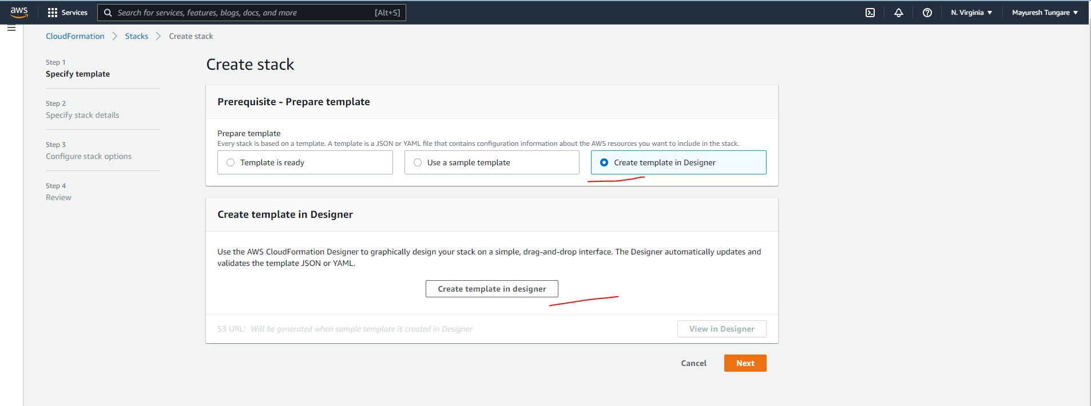

1. After that under Resource types (on Left) choose S3 and under that choose the bucket icon and drag into the grid area. For the window below, choose YAML option and add the code below. Note the code contains instructions to enable versioning on the bucket. The name of the bucket is provided

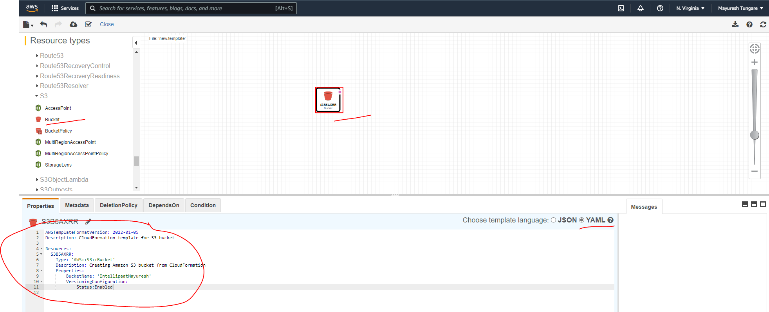

**YAML code is below**:

Resources:

S3Bucket:

Type: 'AWS::S3::Bucket'

DeletionPolicy: Retain

Properties:

BucketName: Intellipaat-Mayuresh

1. After the code is entered, you can save the template as the code is shown below:

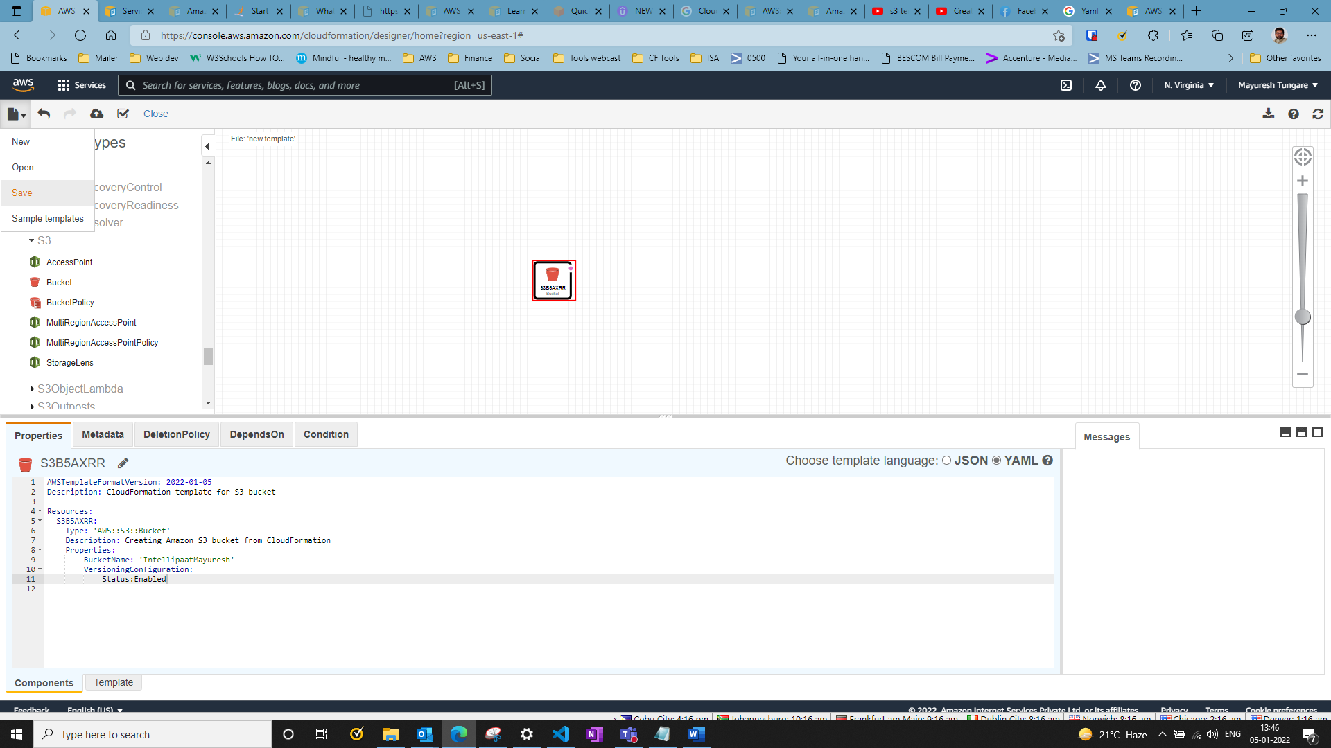

1. You can choose to save either in S3 bucket or as a local file. Thus your CloudFormation template file is now created.
2. Thus, the assignment is now complete.